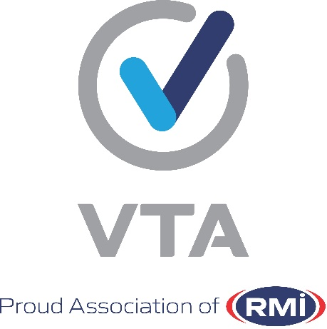
ROADWORTHY INDUSTRY FORUM

ANTI-CORRUPTION & ANTI-FRAUD CHARTER AND UNDERTAKING
PREAMBLE
Road safety is the responsibility of everyone in South Africa. Unroadworthy vehicles lead to loss of life on our roads. All relevant parties and role-players in the roadworthy industry commit themselves to be part of the solution and improvement of road safety and pledge and undertake to do everything in their power to improve road safety.
In so doing, we pledge and undertake to uphold this ANTI-CORRUPTION AND ANTI-FRAUD CHARTER, in the following ways:-
- All relevant parties in the roadworthy industry will act with INTEGRITY in all its dealings with third parties or otherwise, these include their staff, customers, suppliers, government and the Inspectorate of test stations;
- Management of test stations will promote the ANTI-CORRUPTION and ANTI-FRAUD Charter and Undertaking in their businesses by ensuring that approved and sufficient posters and other visual images are displayed;
- Management of test stations will ensure that they implement systems and provide the resources to, in turn, ensure that there is sufficient control within the test station environment to prevent all irregularities;
- Test stations will ensure that everyone involved in their business pledges and undertakes to do the things contained hereinafter (“The Pledge and Undertaking”) as well as The Anti-Corruption and Anti-Fraud Charter and Undertaking as a whole, which will be demonstrated by the signatures of these role players - this includes the proprietors (owners), management representatives, vehicle examiners, eNatis Officers and everyone employed and affiliated at and with the station respectively;
- The document with the signatures shall always be up to date and available at the test station.

THE PLEDGE AND UNDERTAKING
  - I pledge and undertake to behave with complete honesty and trustworthiness;
  - I pledge and undertake that I will act within the boundaries of the law in all aspects of my job;
  - I pledge and undertake not to declare unroadworthy vehicles roadworthy;
  - I pledge and undertake that I will uphold the principals of honour and promise keeping;
  - I pledge and undertake that I will not to participate, directly or indirectly in; or condone any activity involving fraud and/or corruption;
  - I pledge and undertake that I will report any fraudulent transaction that I may become aware of in the course of my business or my job;
  - I pledge and undertake to, in general, do all things lawfully expected of me, by virtue of my signature hereto or which may be communicated by my employer or other authority to ultimately support, promote and advance the objectives of The Pledge and Undertaking and The Anti-Corruption and Anti-Fraud Charter and Undertaking as a whole.
SIGNATURE: CEO OF THE RMI

